### Different Versions of HTML By Priya Pedamkar

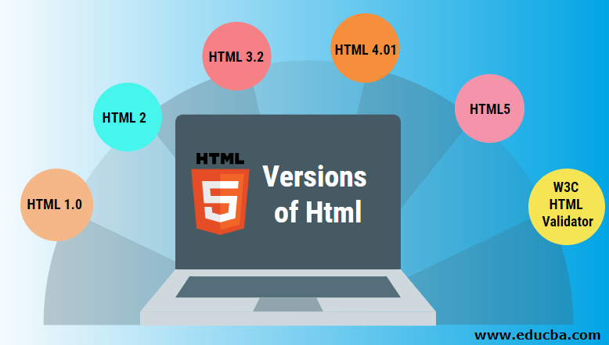

## Introduction to Versions of Html

We are mostly aware of websites. A website is simply a collection of web pages. For creating any web page, we require HTML. An HTML is the element that is responsible for making any web page. HTML stands for HyperText Markup Language. It is a basic markup language used to make any web pages that further comprise to form websites. HTML had evolved so much from the initial stage when it was formed.

**1. HTML 1.0**

* The basic version of HTML has support for basic elements like text controls and images. This was the very basic version of HTML with less support for a wide range of HTML elements. It does not have rich features like styling and other things that were related to how content will be rendered in a browser.
* The initial version of HTML does not provide support for tables, font support, etc., as it provides us in the latest version.
* We would also like to discuss that W3C did not exist before HTML 2.0; hence it does not show details about HTML 1.

**2. HTML 2**

* HTML version 2.0 was developed in 1995 with basic intention of improving HTML version 1.0
* Now a standard got started to develop so as to maintain common rules and regulations across different browsers. HTML 2.0 has improved a lot in terms of the markup tags. In HTML 2.0 version concept of form came into force. Forms were developed, but still, they had basic tags like text boxes, buttons, etc.
* Also, the table came as an [HTML tag](https://www.educba.com/basic-html-tags/). Now, in HTML tag 2.0, browsers also came with the concept of creating their own layers of tags that were specific to the browser itself. W3C was also formed. The main intention of W3C is to maintain standard across different web browsers so that these browsers understand and render HTML tags in a similar manner.

**3. HTML 3.2**

* It was developed in 1997. After HTML 2.0 was developed, the next version of HTML was 3.2
* With version 3.2 of HTML, HTML tags were further improved. It is worth noting that because of W3C standard maintenance, the newer version of HTML was 3.2 instead of 3.
* Now, HTML 3.2 has better support for new form elements. Another important feature what HTML 3.2 implemented was support for CSS. CSS stands for [Cascading Style Sheet](https://www.educba.com/what-is-css/). It is CSS that provides features to make HTML tags look better on rendering it on browsers. CSS helps to style HTML elements.
* With the upgradation of browsers to HTML 3.2, the browser also supported for [frame tags](https://www.educba.com/frame-tag-in-html/), although HTML specifications still do not support frame markup tags.

**4. HTML 4.01**

* It was developed in 1999. It extended the support of cascading styling sheets. In version 3.2, CSS were embedded in HTML page itself. Therefore, if the website has various web pages to apply to the style of each page, we must place CSS on each web page. Hence there was a repetition of the same block of CSS.
* To overcome this thing, in version 4.01 concept of an external styling sheet emerged. Under this concept, an external CSS file could be developed, and this external styling file could be included in HTML itself. HTML 4.01 provided support for further new tags of HTML.

**5. HTML5**

* This is the latest version of HTML. For a developer, it could be used in 2014. It came up with lots of HTML tags support. [HTML5](https://www.educba.com/html5-elements/) provided support for new form elements like input element s of different types; geolocations[support tags](https://www.educba.com/html-geolocation/), etc.

**Let us look at a few of the tags which were added to HTML5**

* **Email –**New HTML5 tag, which was added, is the input element of type email. This is a form tag, although it could be used outside of a form tag also. This tag checks the validation of the input value. It checks whether the value inserted is a valid email.
* **Password –**This is another form tag that was added to receive a password from the user. Being the password type field, the user types in the field are not visible directly to the user but are represented by special symbols. These symbols save the password from getting revealed on the browser.
* **Audio tag –**This is a new audio tag that was implemented in [HTML5](https://www.educba.com/what-is-html5/). This tag helps to add audio to our web page. We can use this tag to embed an audio clip into a web page. This audio tag could be played on a webpage.
* **Semantic tags –**Semantic tags are also known as structural tags. Structural tags are the tags that provide structure to the HTML page. It helps it divide the HTML page into different structures. These structures get combined into an HTML page itself to form an HTML web page. Few of the important HTML semantic tags are figcaption, <header>, <footer>
* **Section tag –**This tag is used to semantic a section in an HTML page. A [section tag](https://www.educba.com/html-section-tag/) represents a section on a web page.

**6. W3C HTML Validator**

An HTML validator is a web-based tool that is used to maintain or check whether a piece of HTML tag or HTML is valid. An HTML validator follows the standard of W3C to validate an HTML page. It follows the W3C standard.

**7. Reference**

Version of HTML, By Priya Pedamkar https://www.educba.com/versions-of-html/